1. Car Rental

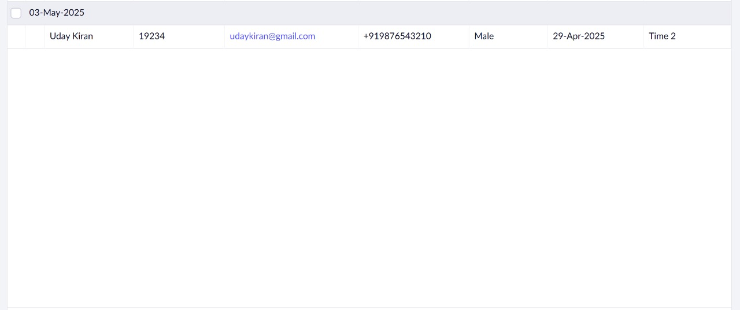

Details

2.Hospital Management

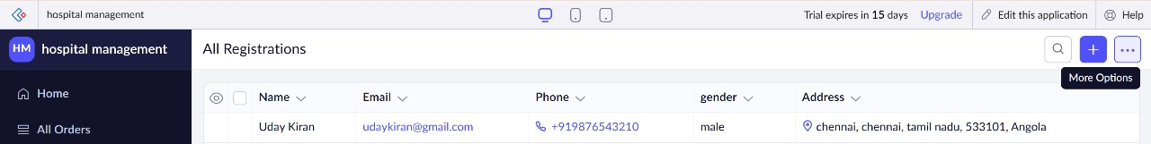

Details

